|  |  |
| --- | --- |
| **Data Structures and Algorithms**  **Science and Data Engineering**  **Universidad Carlos III de Madrid**  **CURSO 2021-2022** |  |



**Final Exam. May 20th, 2022.**

**Name:**

Instructions:

* Exam duration: 60’.
* Download and uncompress the.zip file.
* Solution must be provided within.py file. Add a comment at the beginning of the file with your name, surname and NIA.
* DO NOT MODIFY unittest file. This is a file to help you check whether your implementation works as intended.
* During the exam you will only be allowed to work on your chosen Python IDE (i.e. Spyder, Pycharm, VSCode…). You are not allowed to check any other resources such as slides, code samples from internet, etc.
* The teacher will do some time checks during the session. He will send a reminder when the exam is about to finish (5 mins left) to upload your solution (only code file) to Aula Global (reduced group).
* Make sure that you upload the correct version before leaving, It’s your responsibility.
* Mobile phones and any other device must be off.
* You cannot leave the classroom before 30 mins have passed.
* You cannot go to the toilet during the exam.

**Problem statement:** We provide a basic implementation of a BinaryTree class where we will store non-negative integer numbers. You must implement an algorithm, *right_sum(),* that computes the sum of all nodes that are placed **at the rightmost position of each level of the tree**. For example, given the following tree (which contains 4 levels) the function should yield 17, since nodes 2, 10, 1 and 4 are placed at the rightmost position of each level:

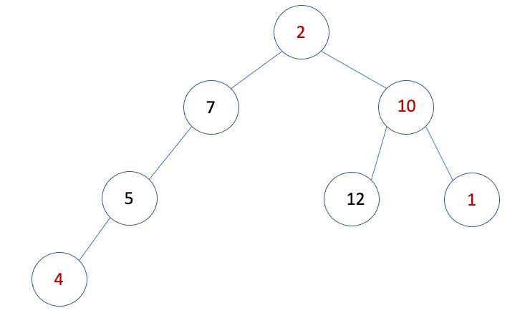

If the tree is empty, the method must return 0.

You are NOT allowed to use Python lists, queues or any other data structure. Proposed code must solve the problem, be able to handle unexpected inputs and be efficient in terms of time and space complexity. Code must be readable and easy to follow.